Lab Objective

Configuring Zone Scavenging

**Lab Procedures**

**1.** On RWDC01, with DNS Manager console, right-click the RWDC01 and click *Set Aging/Scavenging for all Zones*. The Server Aging/Scavenging Properties dialog box opens as shown in Figure 9-3.

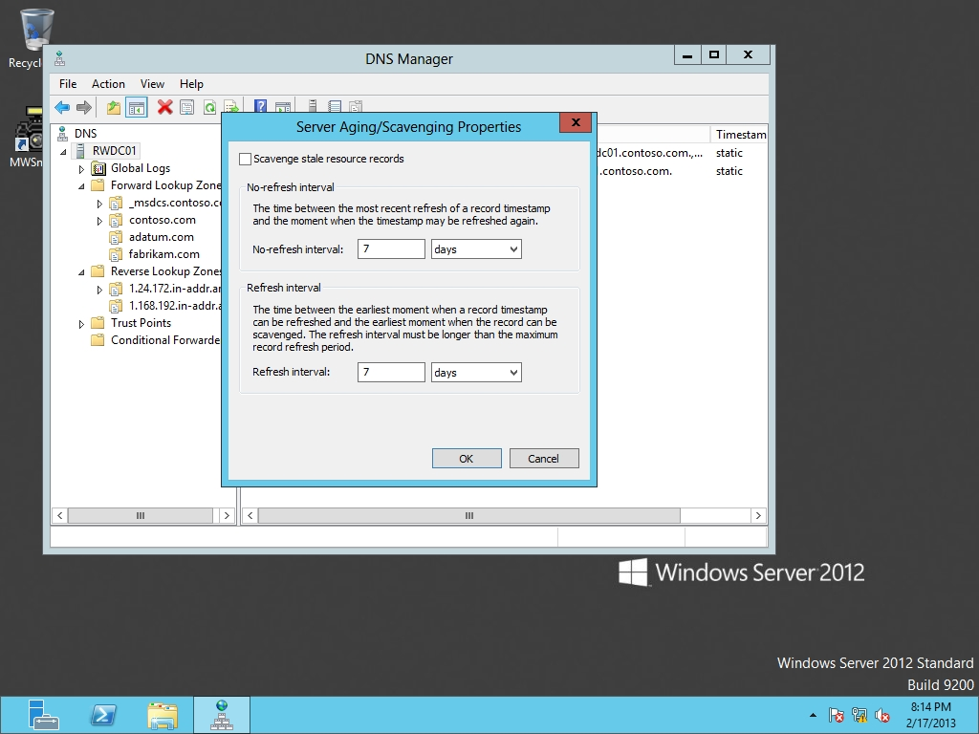

Figure 9-3

Configuring aging and scavenging settings

**2.** Click the *Scavenge stale resource records* option.

**3.** Click the OK button to close the *Server Aging/Scavenging Properties* dialog box.

**4.** Click to enable the *Apply these settings to the existing Active Directory-integrated zones* option. Click OK to close the Server Aging/Scavenging Confirmation dialog box.

**5.** Right-click the adatum.com zone and click Properties.

**6.** On the General tab, click the Aging button. The Zone Aging/Scavenging Properties dialog box opens.

**7.** Click to enable the *Scavenge stale resource records* option.

**8.** Take a screen shot of the DNS Manager window by pressing Alt+Prt Scr and then paste it into your Lab07_worksheet file in the page provided by pressing Ctrl+V.

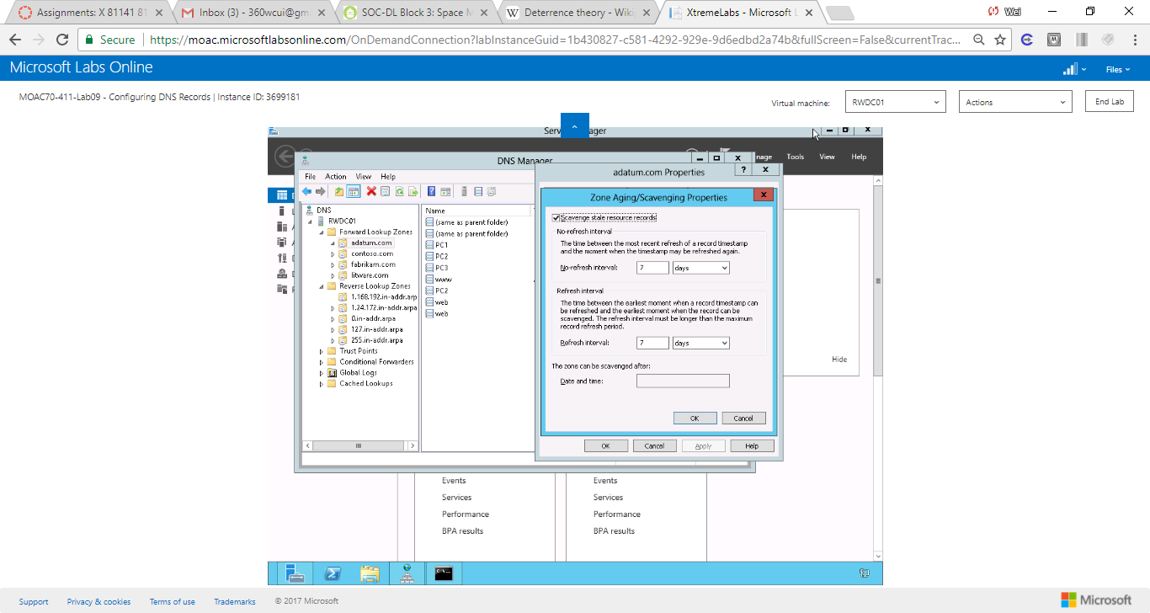

Figure A screenshot of enable the Scavenge stale resource records option

**9.** Click the OK button to close the *Server Aging/Scavenging Properties* dialog box.

**10.** When you are prompted to apply aging/scavenging settings to the Standard Primary zone, click Yes.

**11.** Click the OK button to close the Properties dialog box.

**Lab Summary**

With dynamic addresses, often resource records will be added to a DNS zone, and will remain there unless they are manually deleted or scavanged. During this exercise, I configured zone scavenging.

The DNS Server service supports aging and scavenging features. These features are provided as a mechanism for performing cleanup and removal of stale resource records, which can accumulate in zone data over time. With dynamic update, resource records are automatically added to zones when computers start on the network. However, in some cases, they are not automatically removed when computers leave the network. For example, if a computer registers its own host (A) resource record at startup and is later improperly disconnected from the network, its host (A) resource record might not be deleted. If your network has mobile users and computers, this situation can occur frequently.